**Standing Up an Amazon Aurora Database with an Automatically Rotated Password Using AWS Secrets Manager**

**Hands-on Lab**

We are going to explore using Amazon Athena, Amazon S3, and VPC Flow Logs to deploy an easily searchable analytics platform using SQL-like queries.

**Objectives**

* Create the VPC Flow Log and Generate Records
* Set up Amazon Athena
* Create the Amazon S3 Bucket

**Architecture**

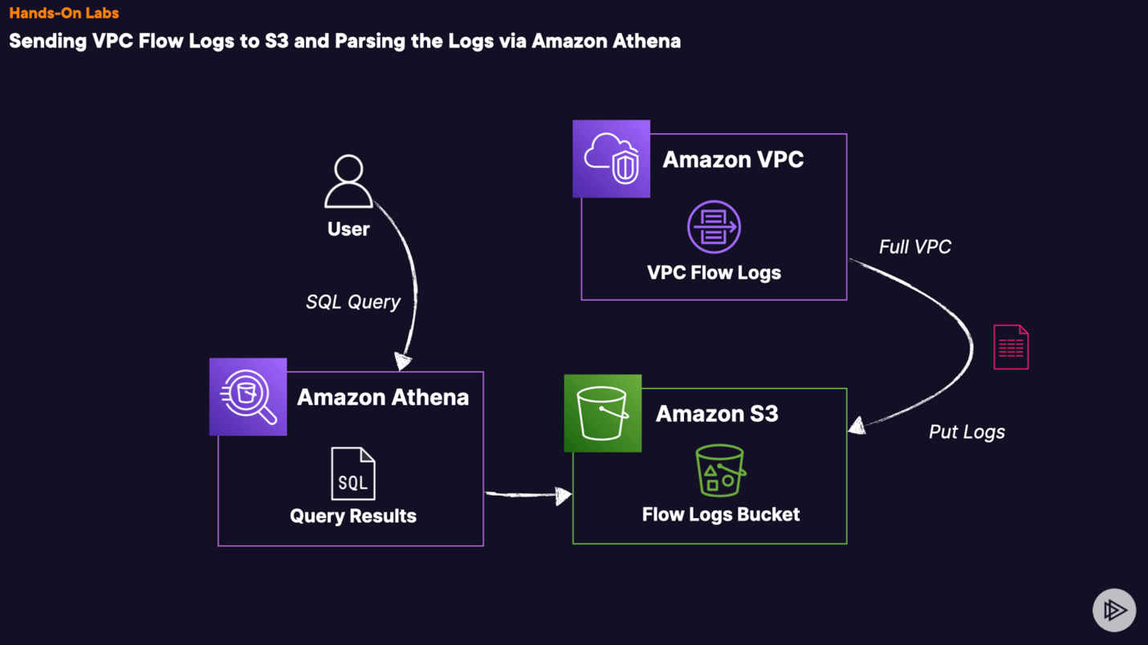

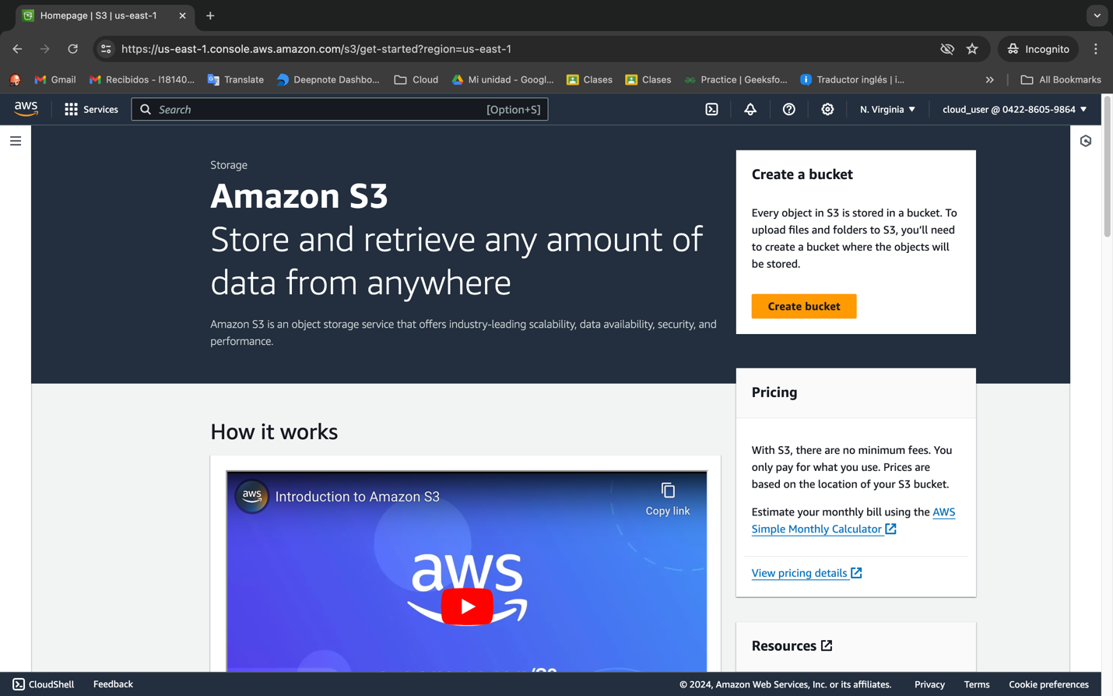

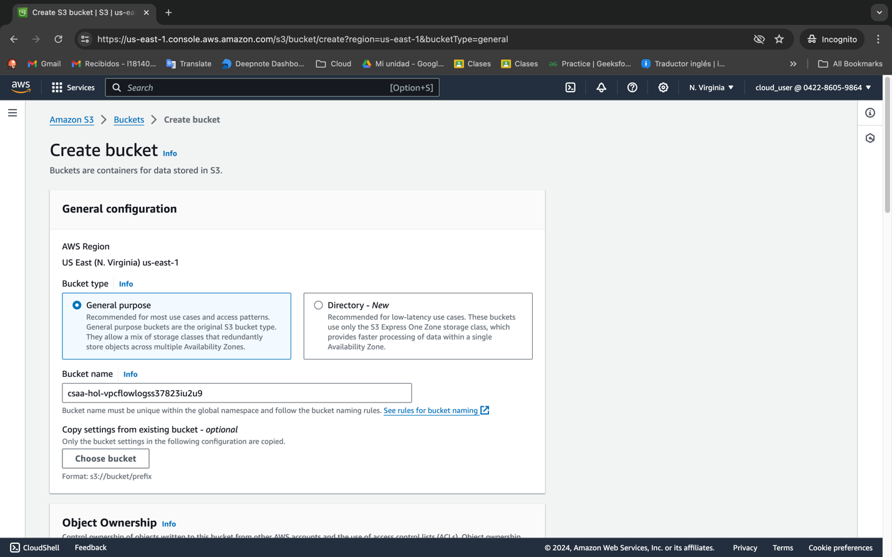

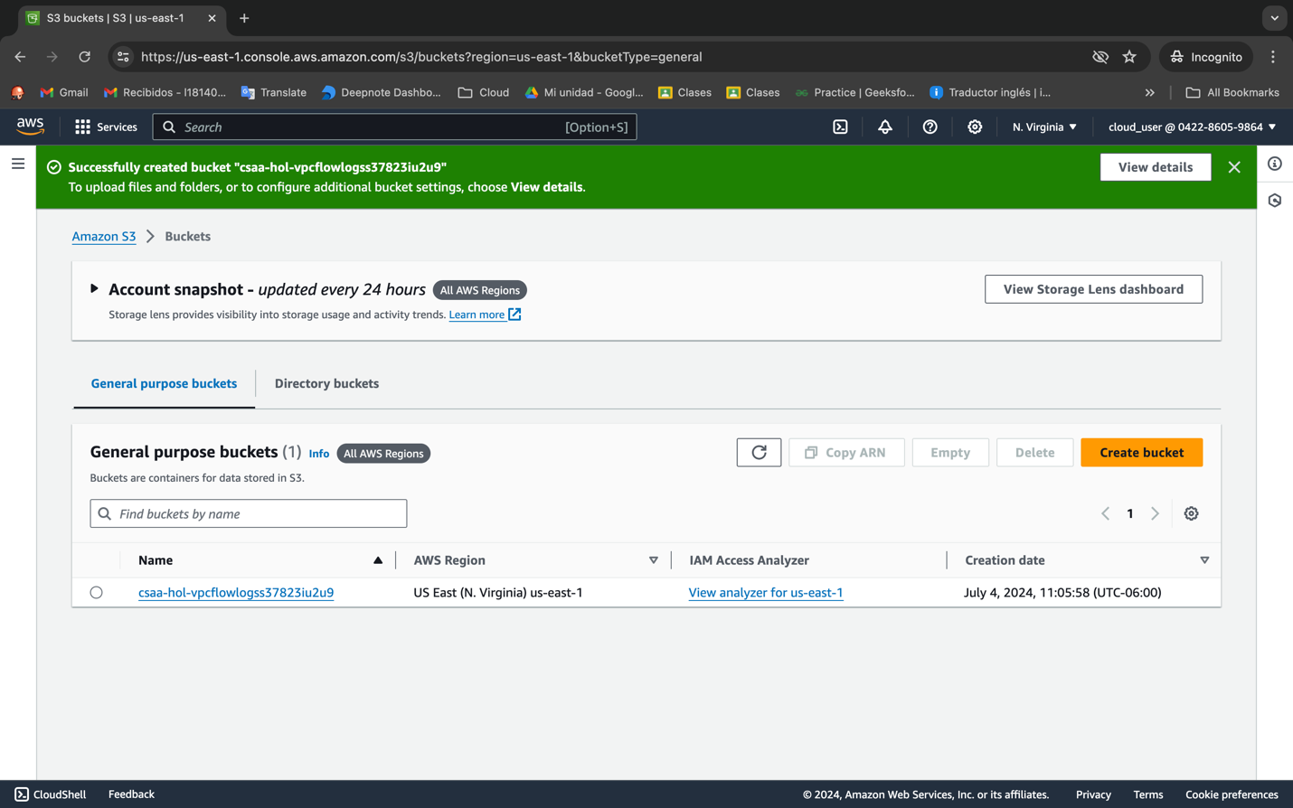

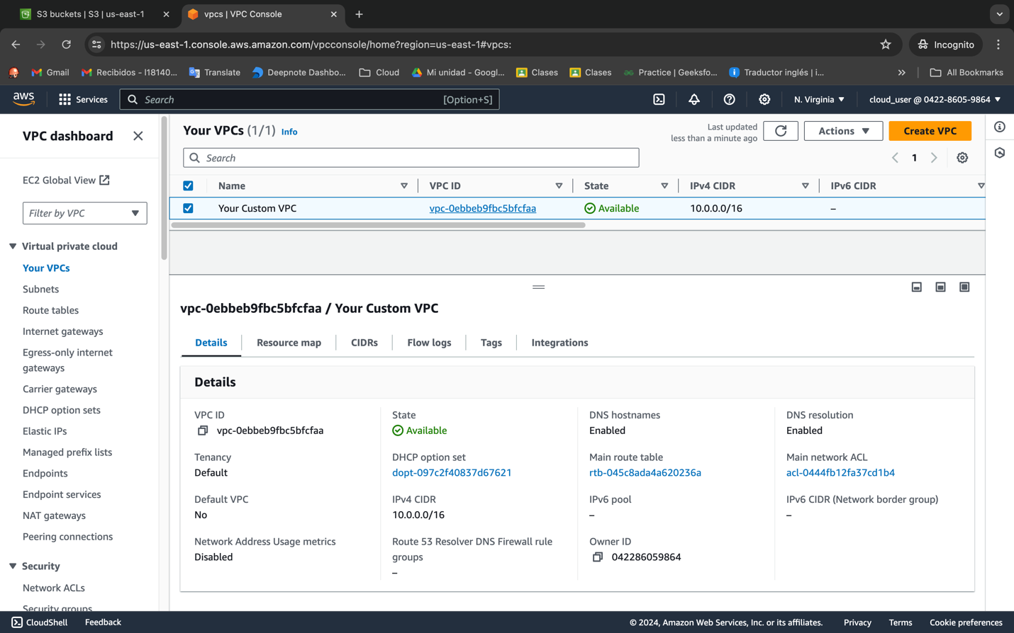

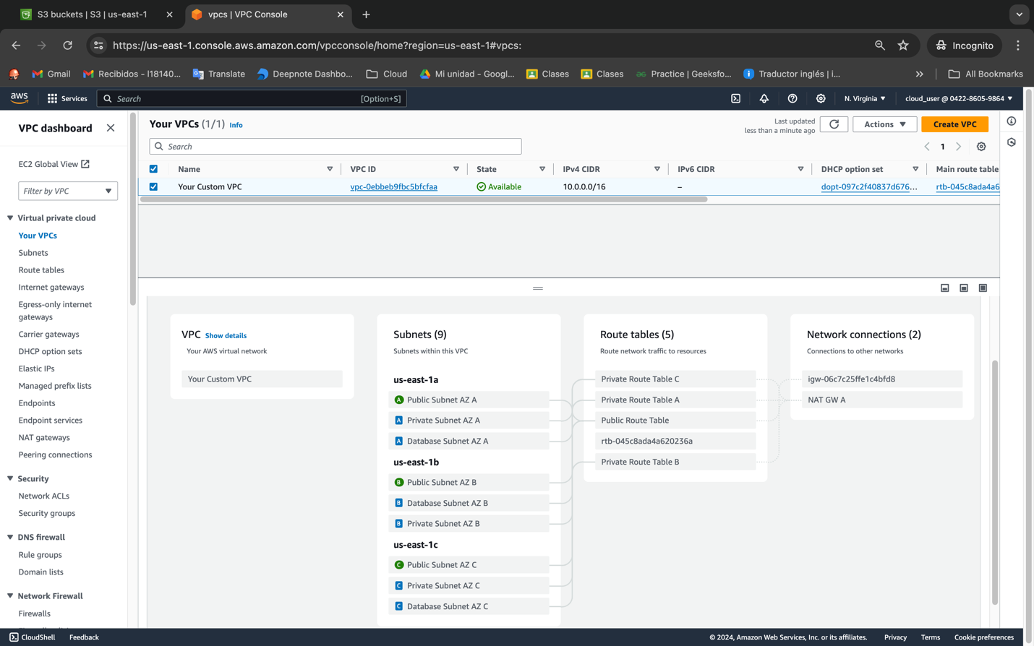

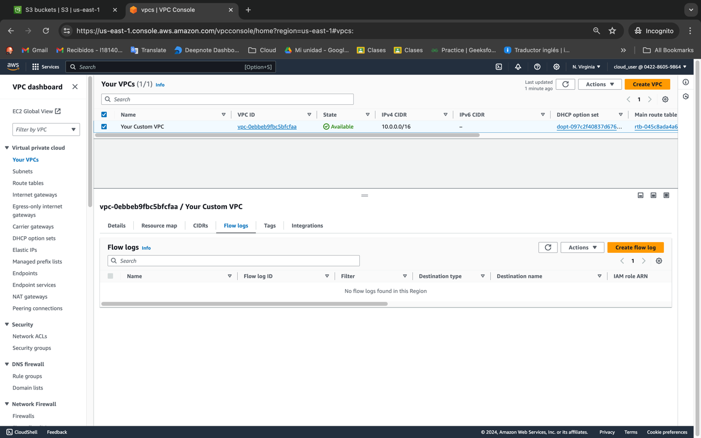

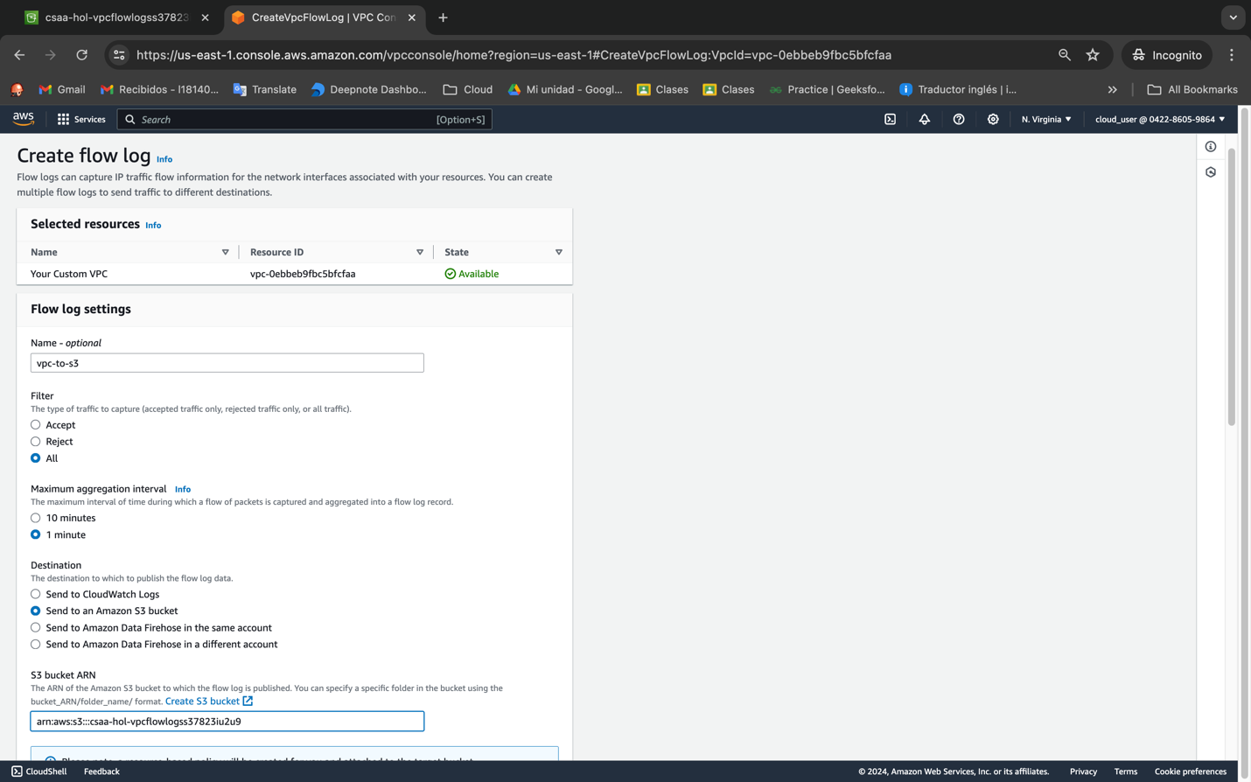

Parquet because athena performance better also hive…

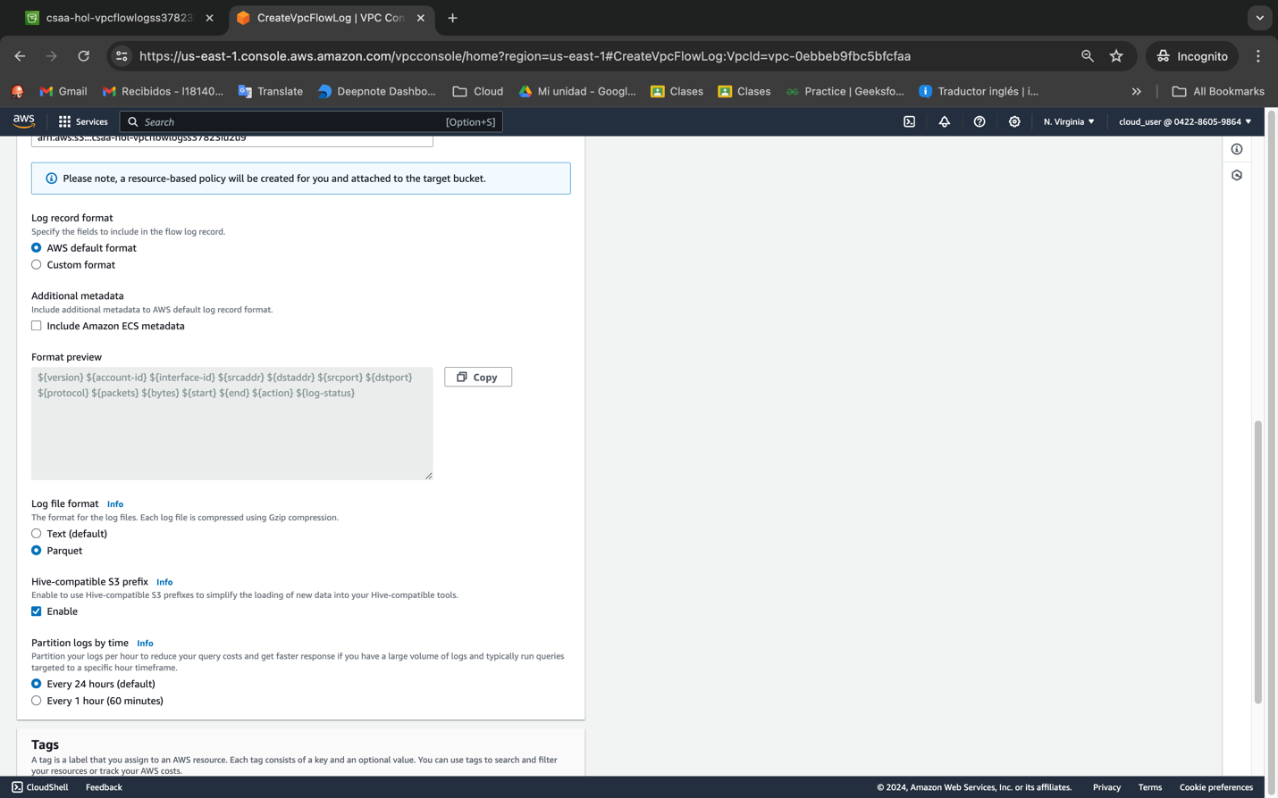

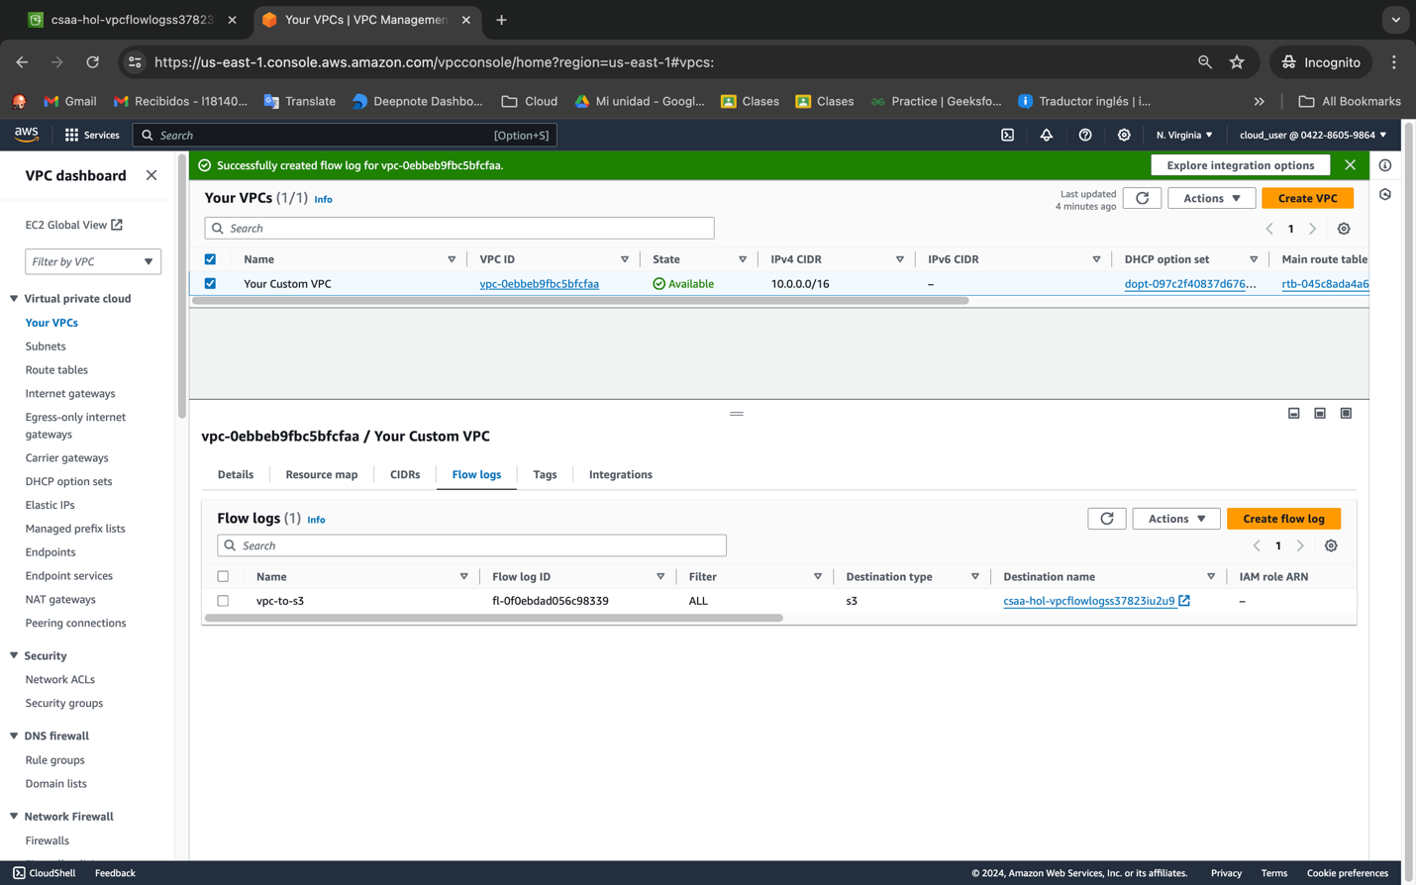

You cant edit, need to create a new one

* Browse to the DNS entry for OurApplicationLoadBalancer **using HTTP** and refresh a couple of times to generate traffic
* Wait a few minutes and refresh the S3 objects list until you start seeing objects generated before you move on

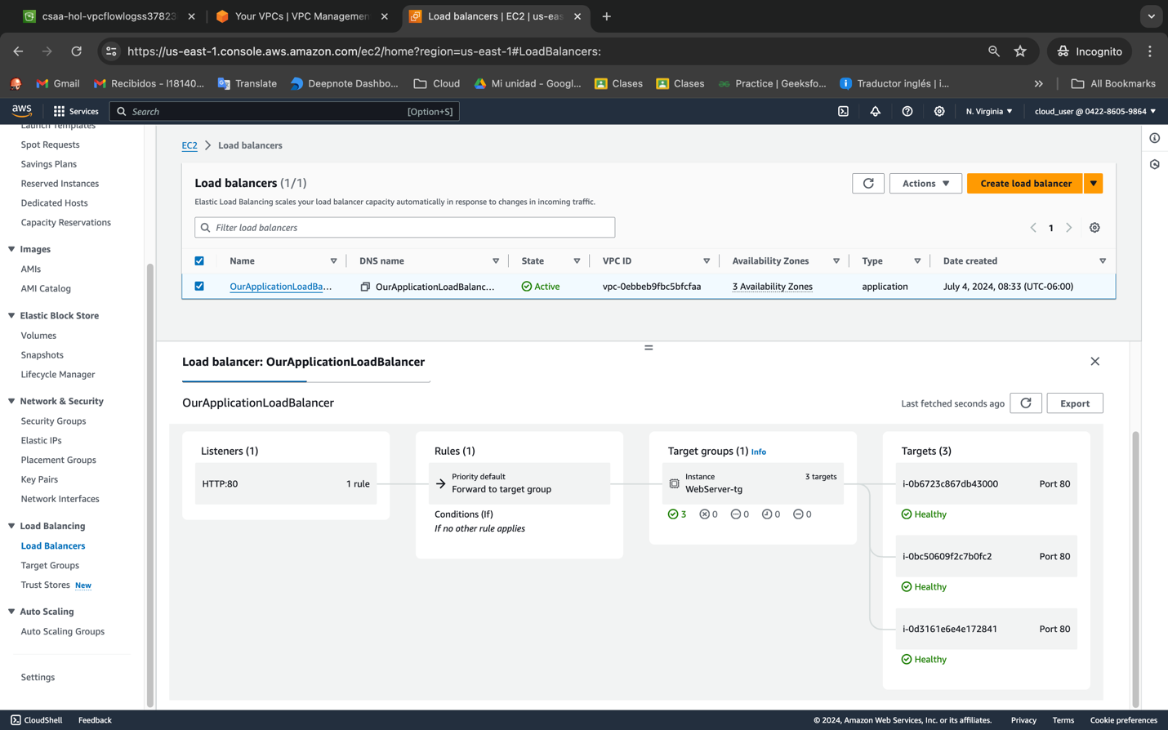

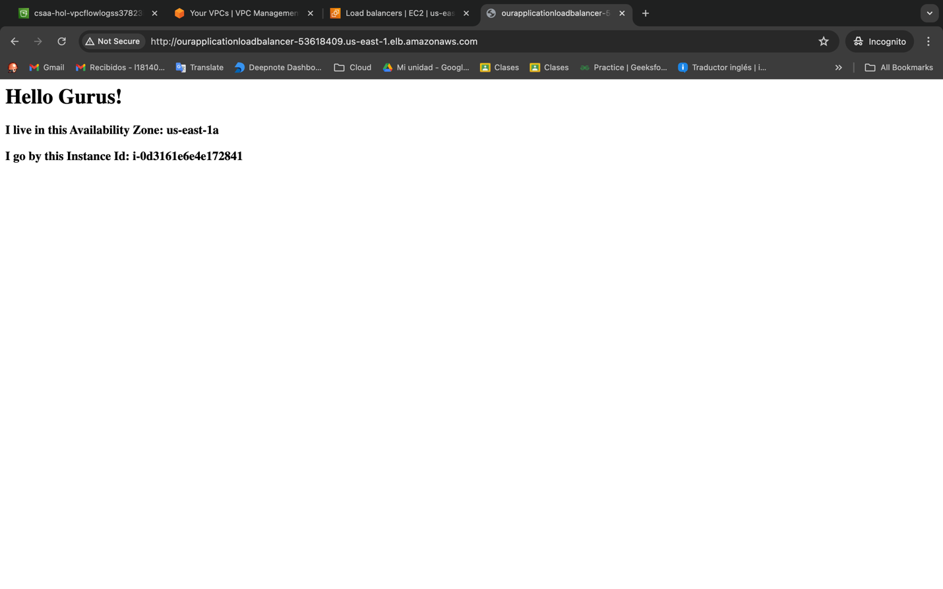

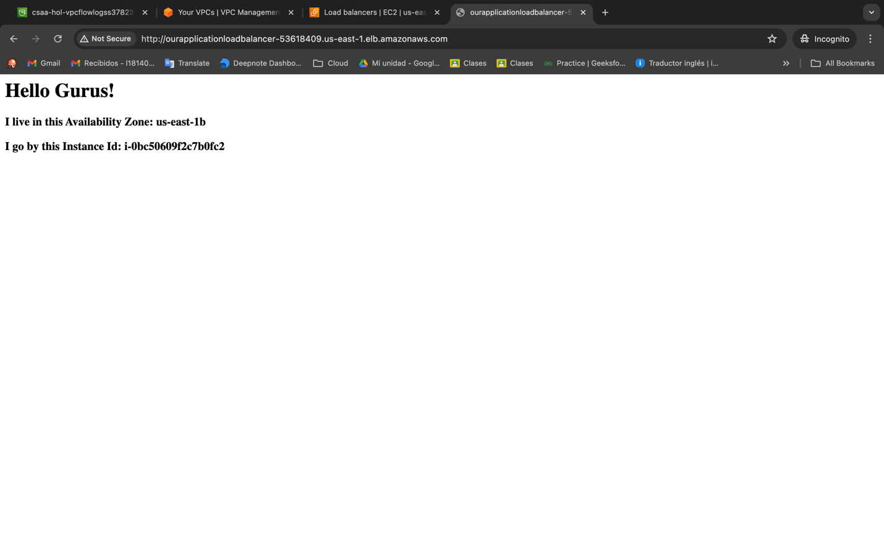

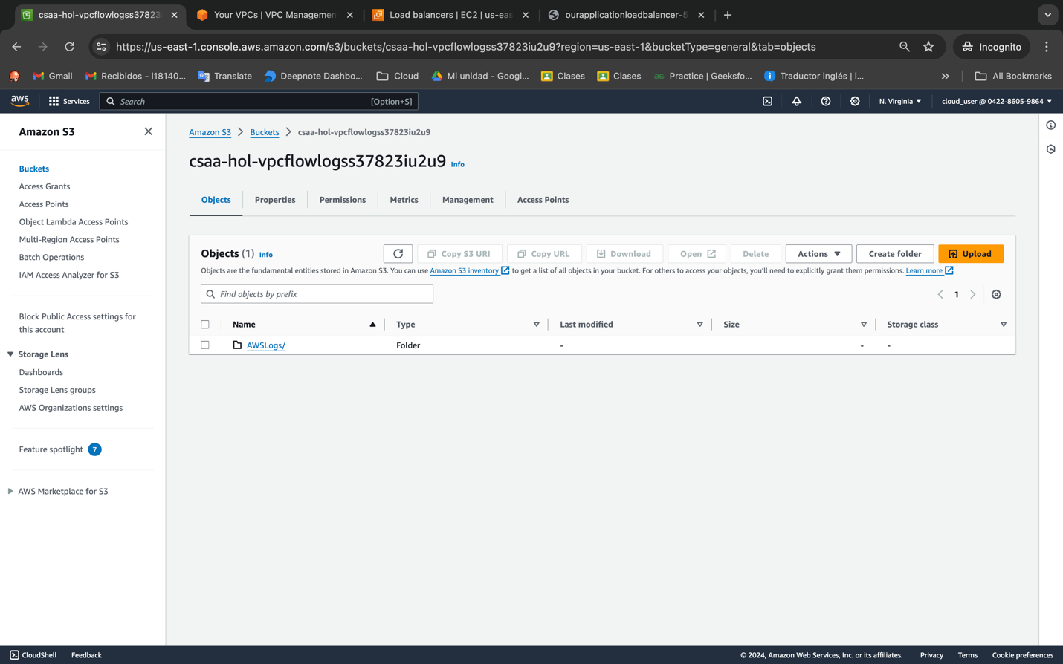

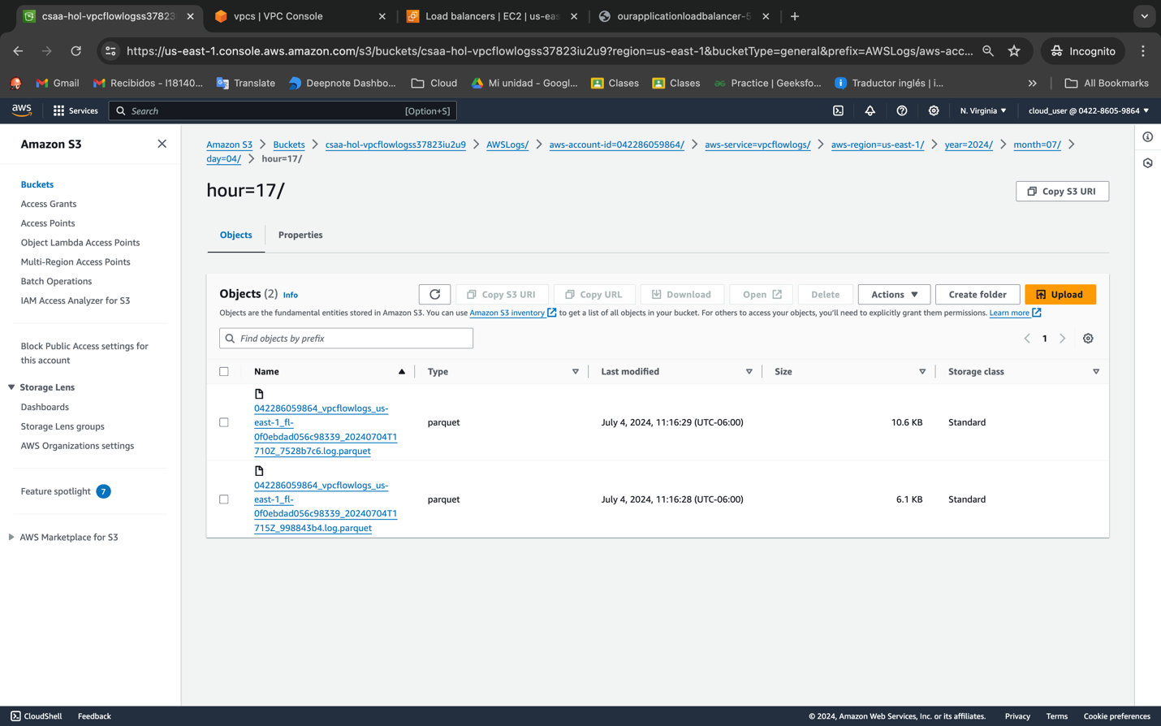

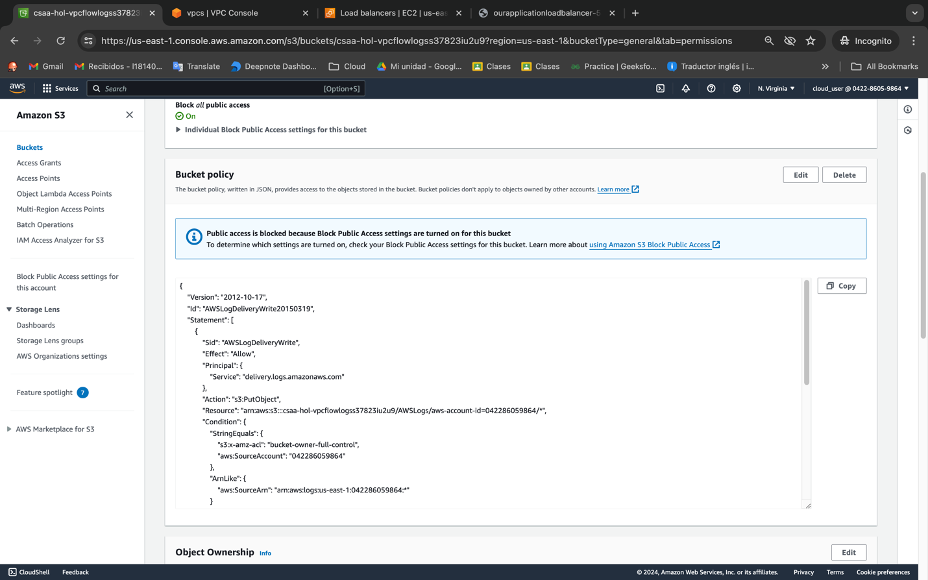

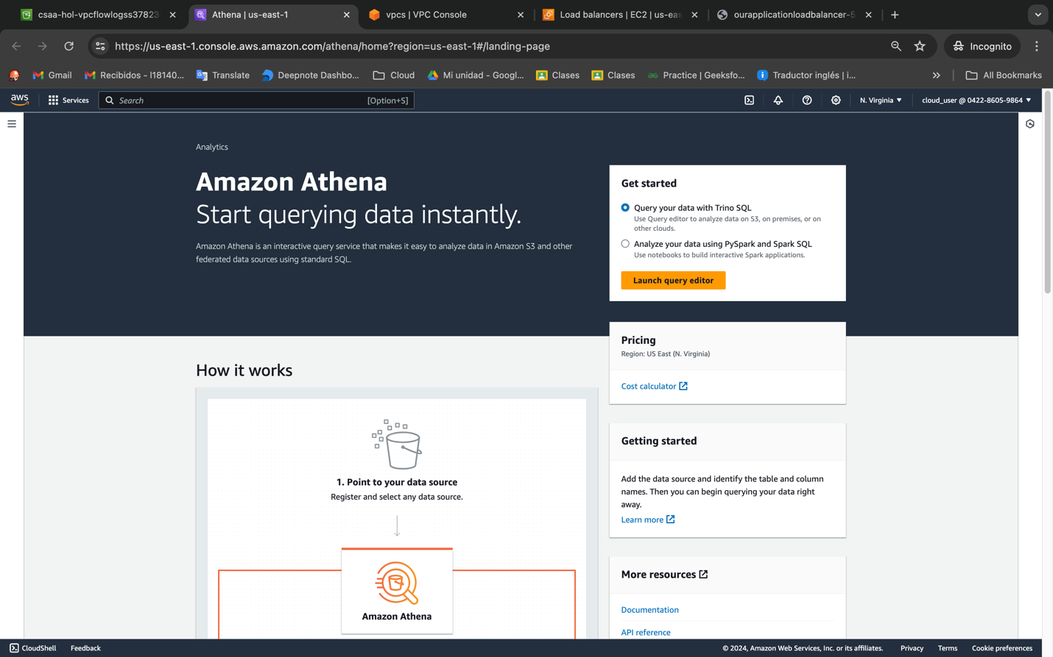

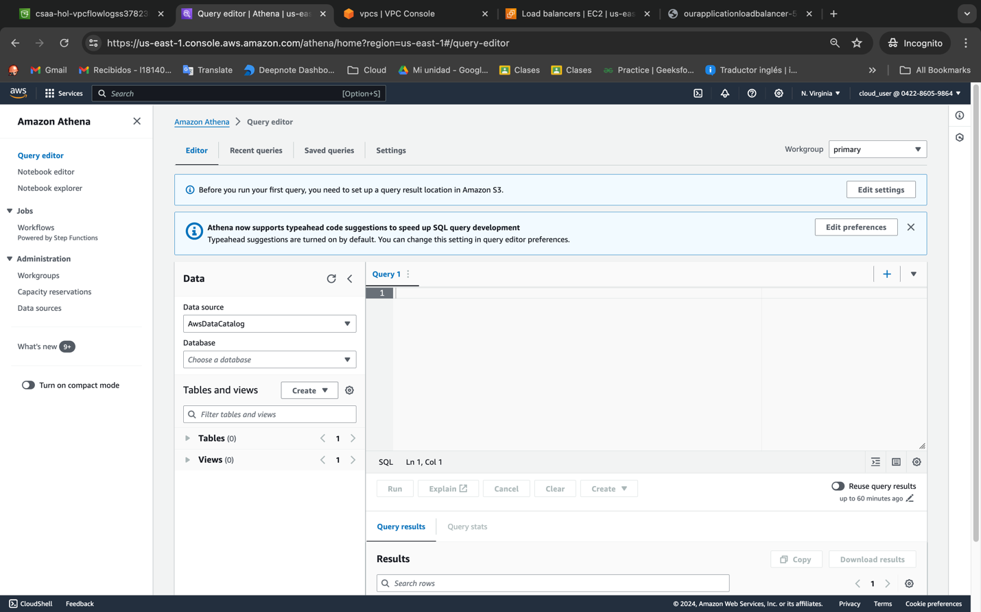

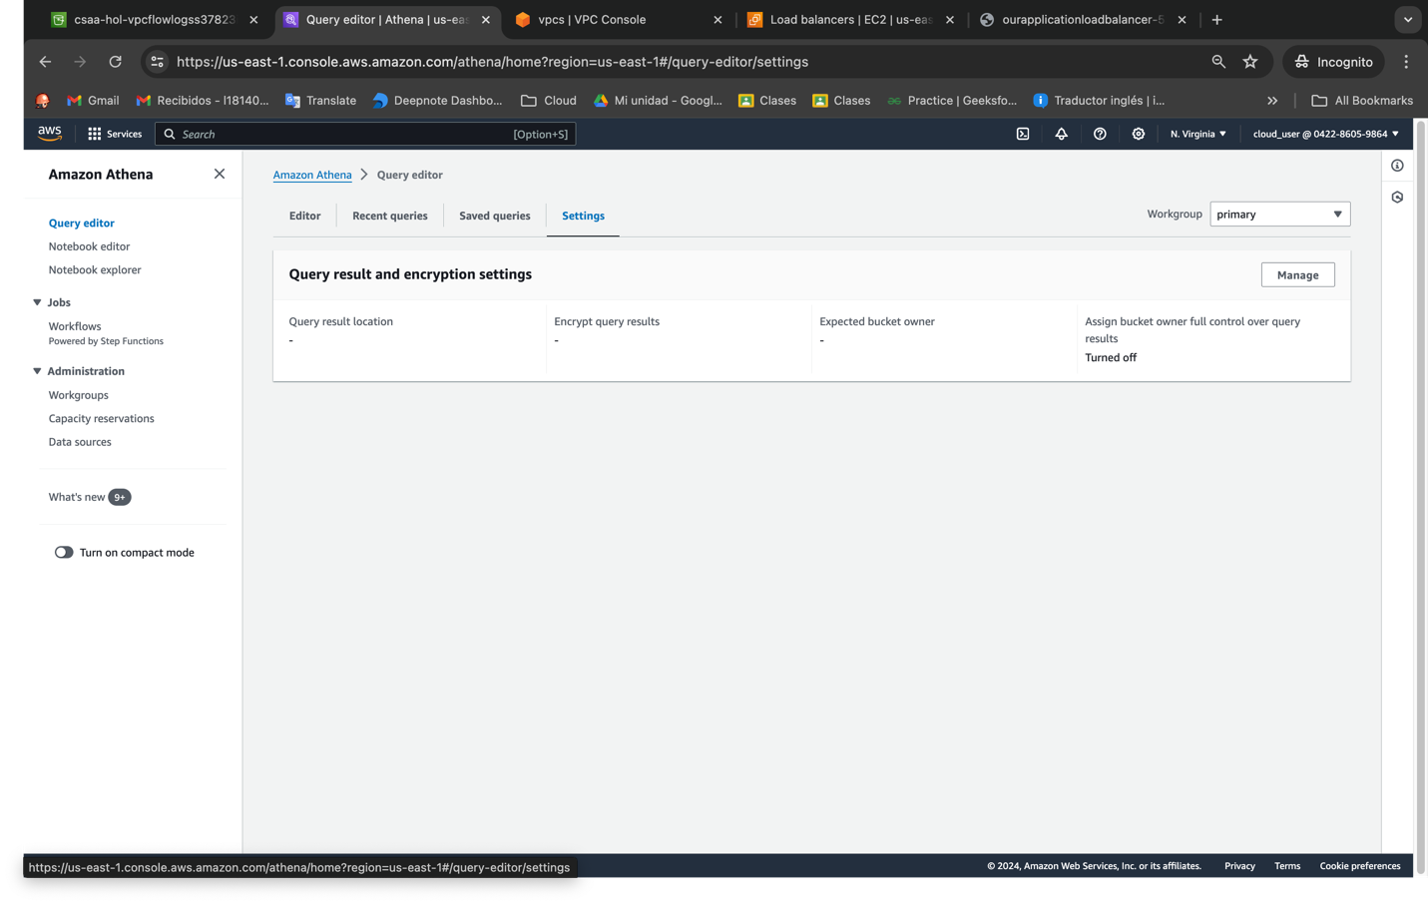

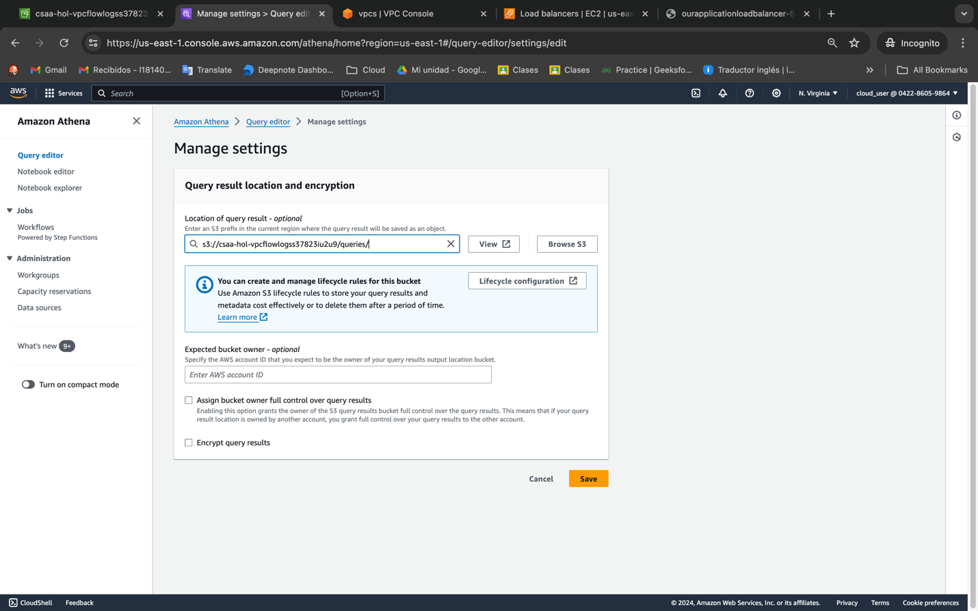

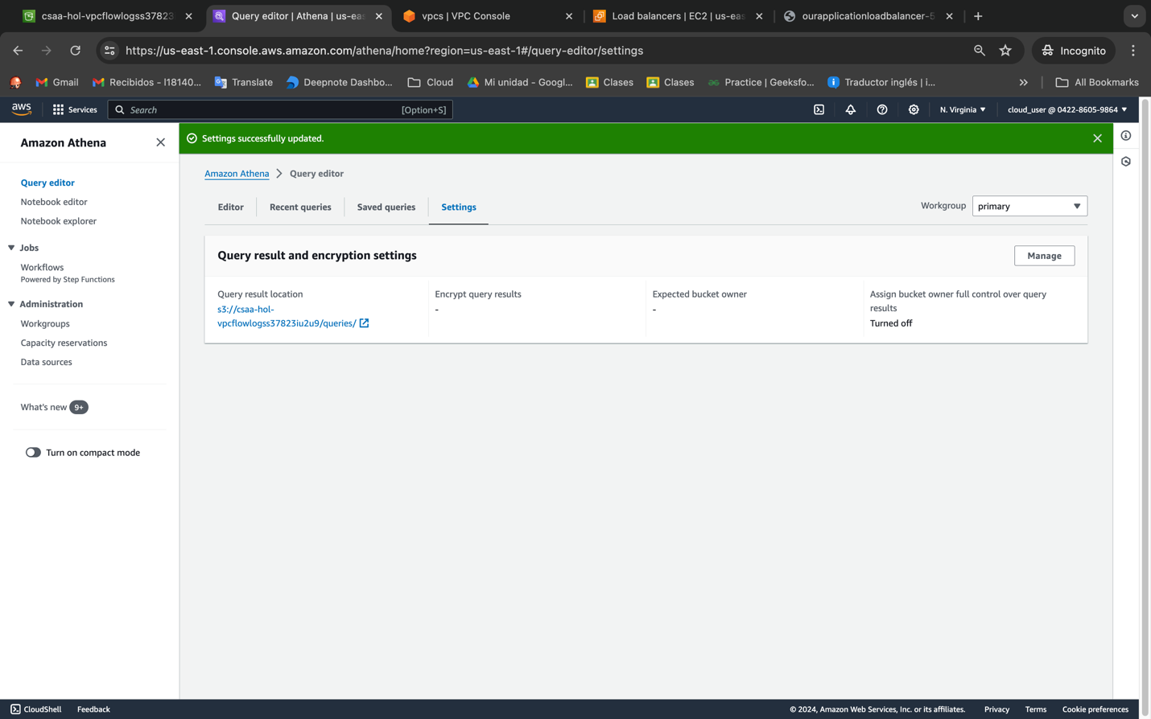

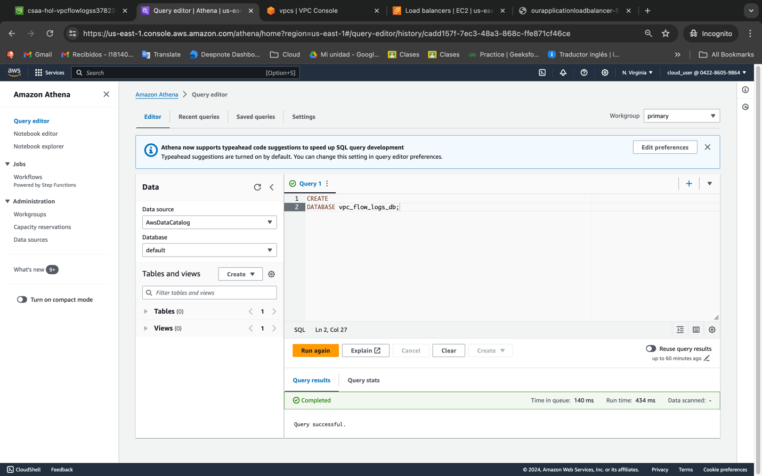

CREATE EXTERNAL TABLE IF NOT EXISTS `vpc_flow_logs` ( version int, account_id string, interface_id string, srcaddr string, dstaddr string, srcport int, dstport int, protocol bigint, packets bigint, bytes bigint, start bigint, `end` bigint, action string, log_status string ) PARTITIONED BY ( `aws-account-id` string, `aws-service` string, `aws-region` string, `year` string, `month` string, `day` string, `hour` string ) ROW FORMAT SERDE 'org.apache.hadoop.hive.ql.io.parquet.serde.ParquetHiveSerDe' STORED AS INPUTFORMAT 'org.apache.hadoop.hive.ql.io.parquet.MapredParquetInputFormat' OUTPUTFORMAT 'org.apache.hadoop.hive.ql.io.parquet.MapredParquetOutputFormat' LOCATION 's3://BUCKET_NAME/AWSLogs/' TBLPROPERTIES ( 'EXTERNAL'='true', 'skip.header.line.count'='1' )

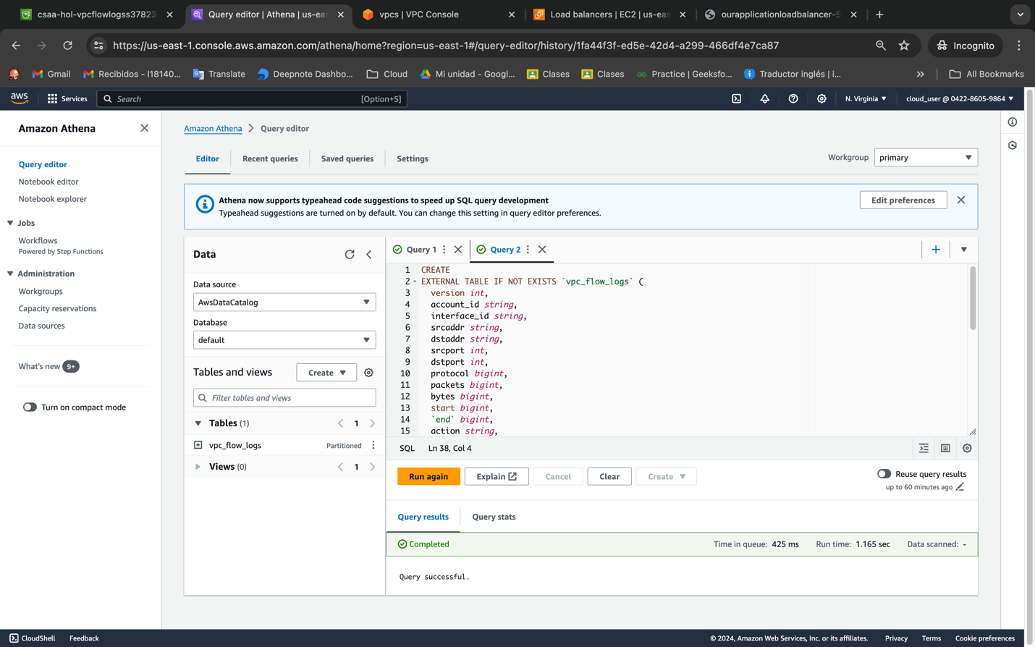

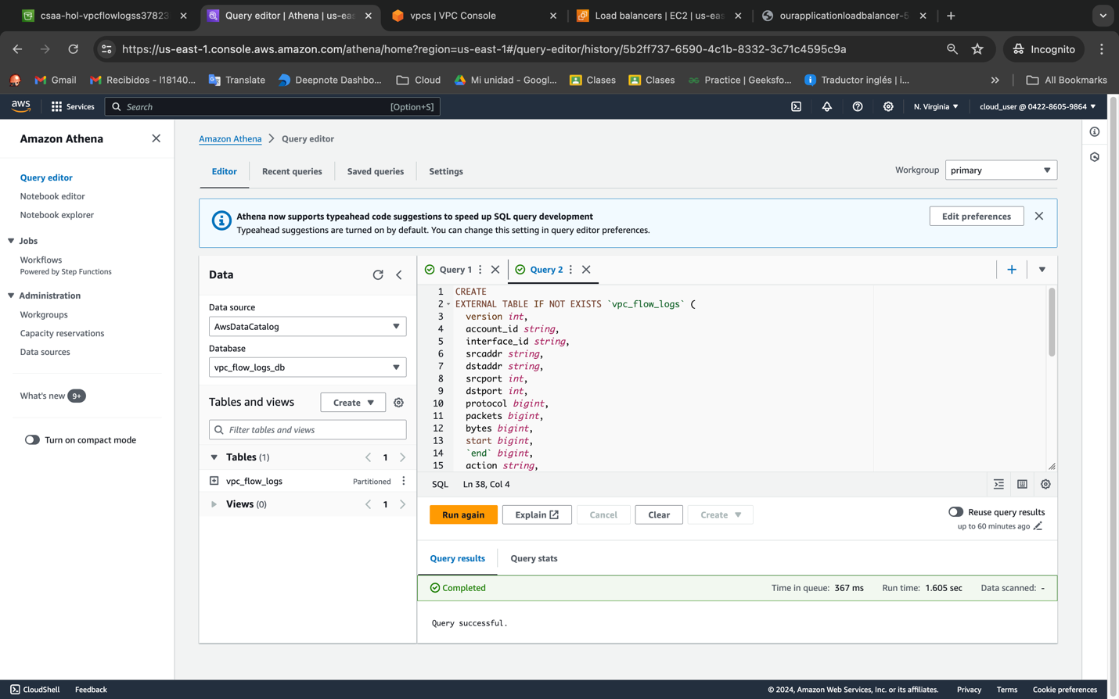

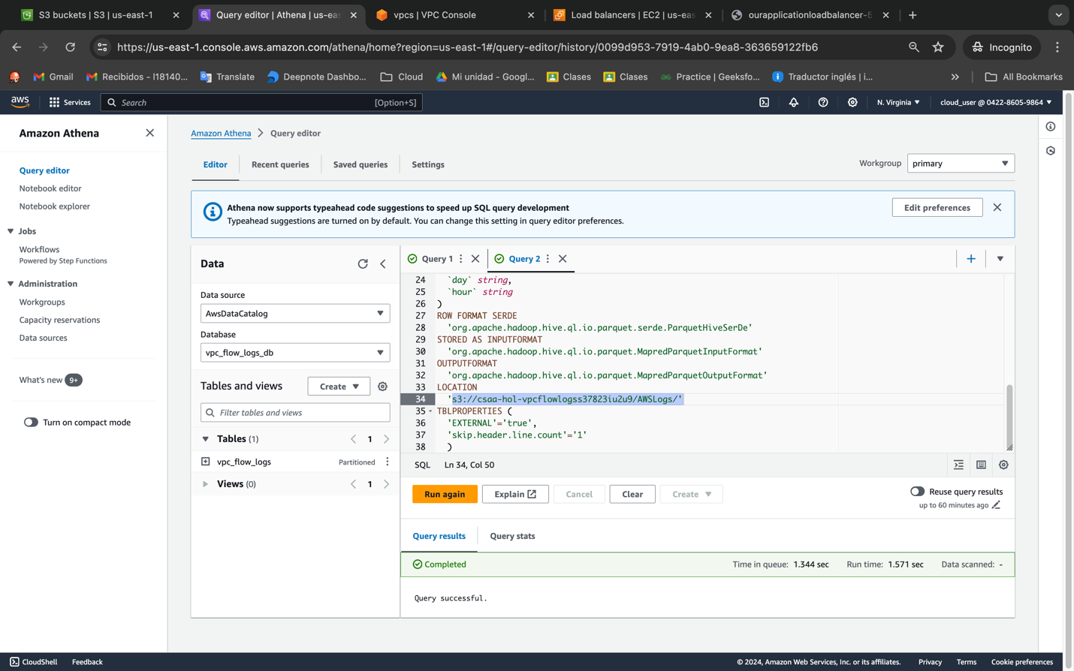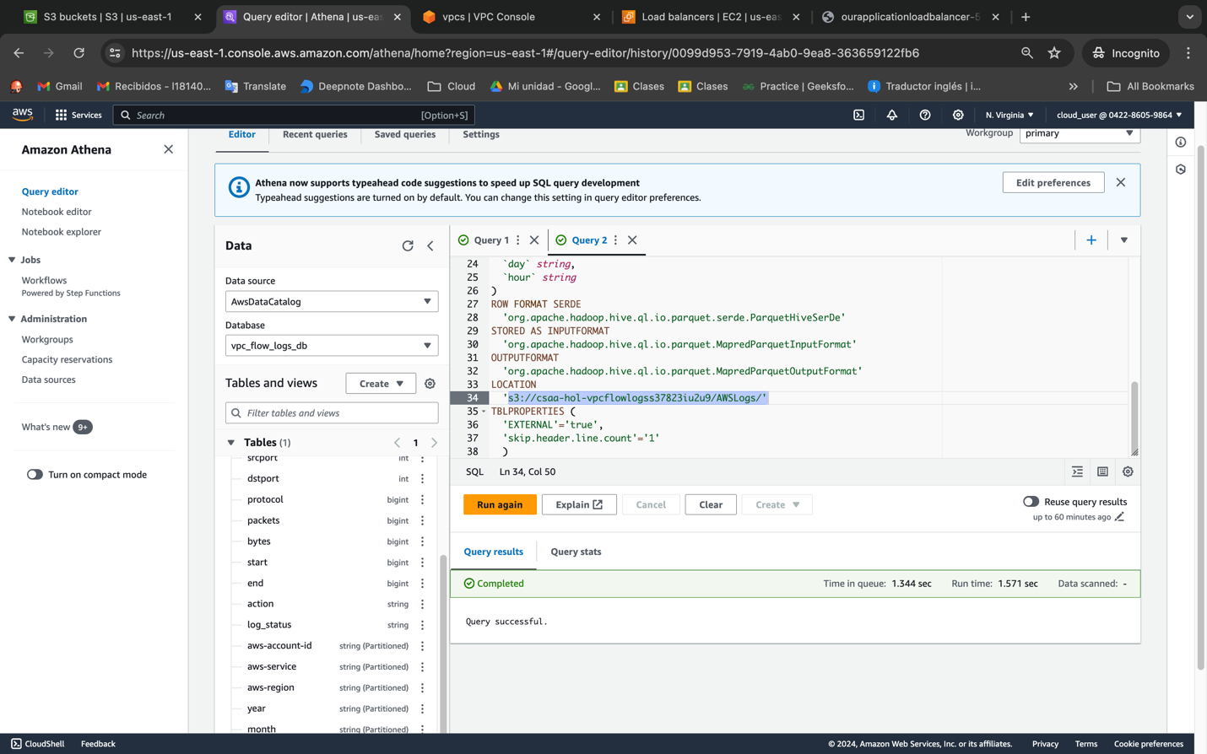

Copy and then paste in the following SQL code which loads the Hive partitions in the metastore and repairs the table so we can query them. (*If you get an error code, follow the steps at the bottom of the guide titled****Fix Errors****and then restart the process in Athena again*):

